**Week 2 – Linux Security Compliance Report**

Student Name:

Faisal Alawi

Ahamd

Mohammed  
  
[PCI DSS Compliance Auditor](https://github.com/Faisal1alawi/pci-dss-compliance-auditor)

1. Objective

The goal of this project is to build a simple automated Linux security compliance auditing tool using Python and SSH. The tool collects system information, checks SSH configuration, firewall rules, and password policies, then generates a security compliance report.

2. Environment

- Operating System: Kali Linux (VirtualBox)

- Programming Language: Python 3

- Libraries: Paramiko, Linux system utilities

3. Tools Used

- Kali Linux

- Python

- Paramiko (SSH Library)

- Linux System Utilities

4. Implementation Steps

1. Install Kali Linux inside VirtualBox.

2. Setup Python virtual environment.

3. Install required Python libraries.

4. Develop Python auditing script using Paramiko.

5. Connect to target system using SSH.

6. Execute security compliance commands.

7. Generate security compliance report.

5. Results

The scan successfully collected system information, verified SSH service status, checked open ports, firewall configuration, and password policies. The final security compliance report was generated and saved locally.

6. Screenshots

Linux OS verification

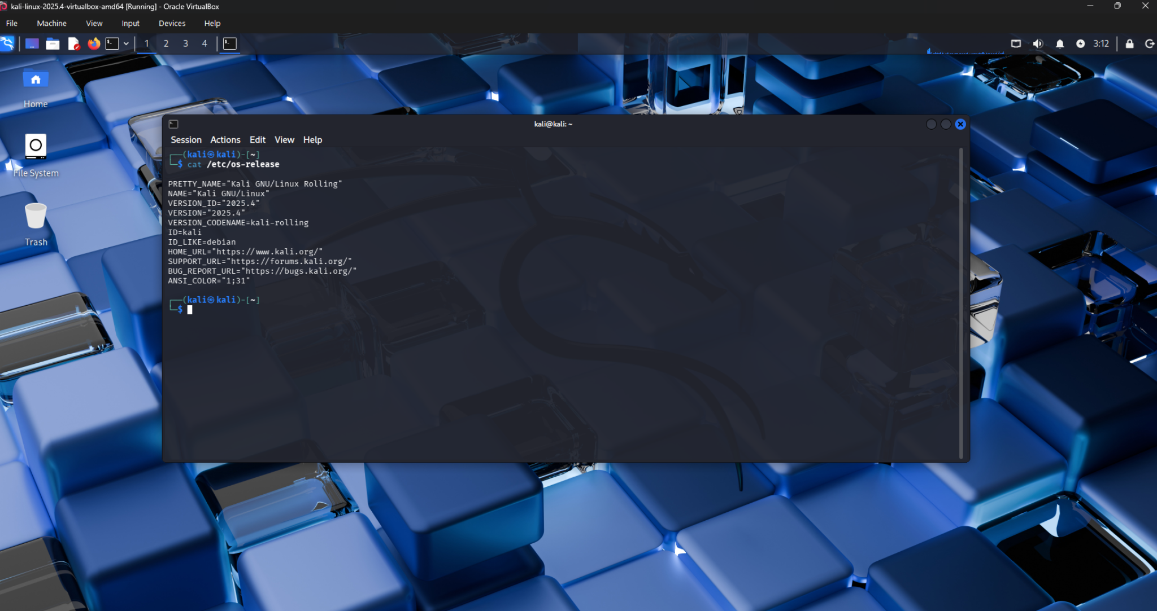

Python & Virtual Environment verification

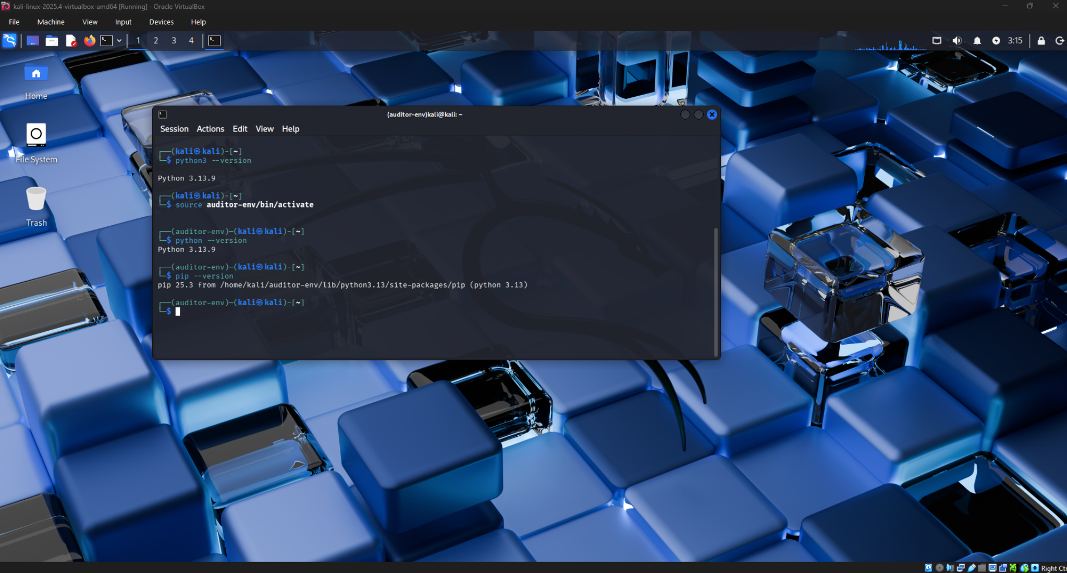

SSH service status

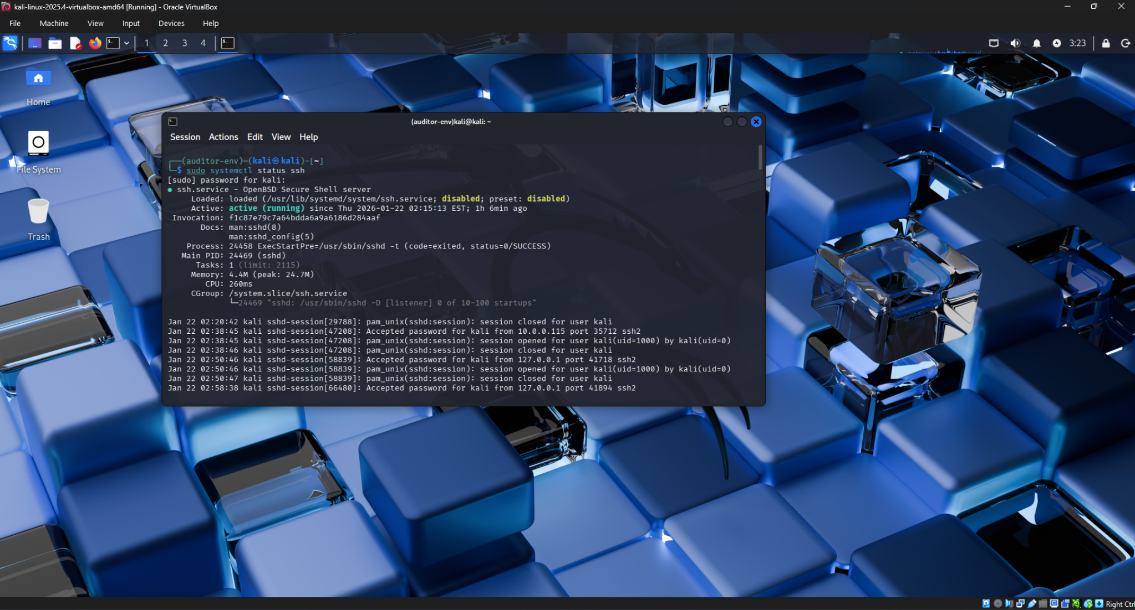

Running security scanning script

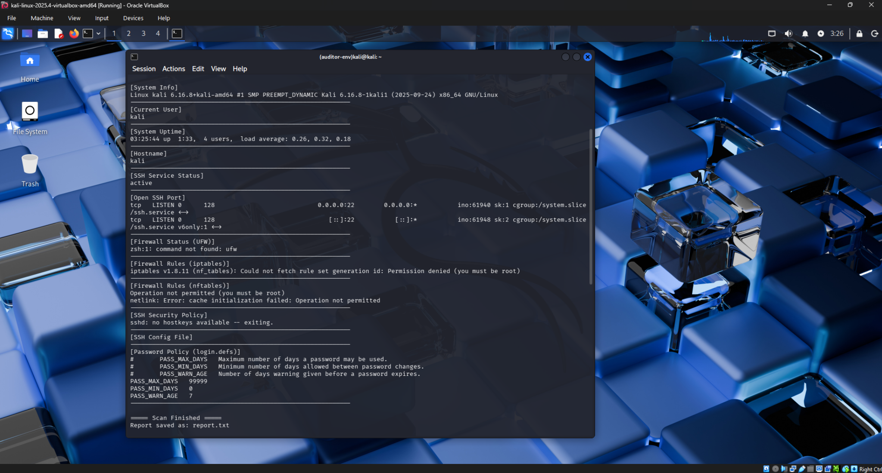

Generated compliance report output

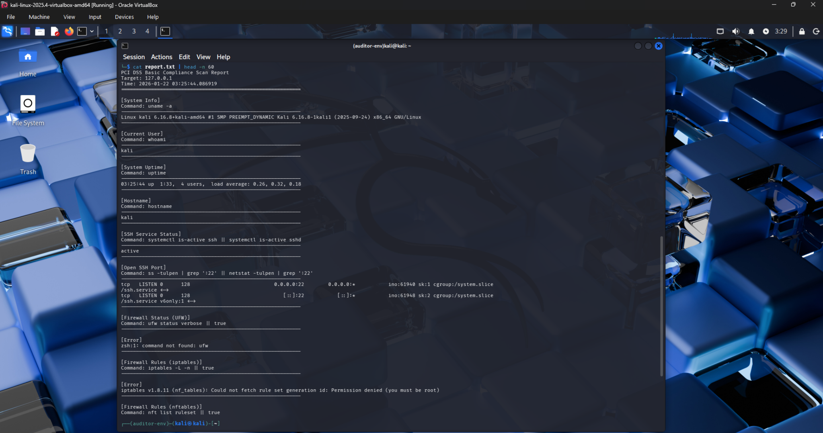

**7. Conclusion**

This project demonstrates how automated security compliance scanning can help system administrators monitor system security and identify misconfigurations. The tool provides a simple and effective approach to auditing Linux systems.